## 

## **Nintendo@E3!… It's Nintendo Society News Time!**

E3 is this week! And so is the release of ARMS, which will debut at the society next week!

Let’s get to this week's announcements:

### **Nintendo Society Clothing**

18765743_1730840656942610_6725651492572826986_n.jpg18622677_1730840653609277_2397497493689820442_n.jpg

Buy by tomorrow before prices go up by £2! They’ll still be available throughout summer, and they’ll be reduced down back to these prices sometime during next academic year so no worries if you have no money now!

Link to buy here: <http://customclubclothing.co.uk/shop/index.php?c=248>



### **Monday 12/6, R1.03, 5pm onwards**

Monday is fun again! We are back from exams with some of the greatest multiplayer games on Wii U and Switch!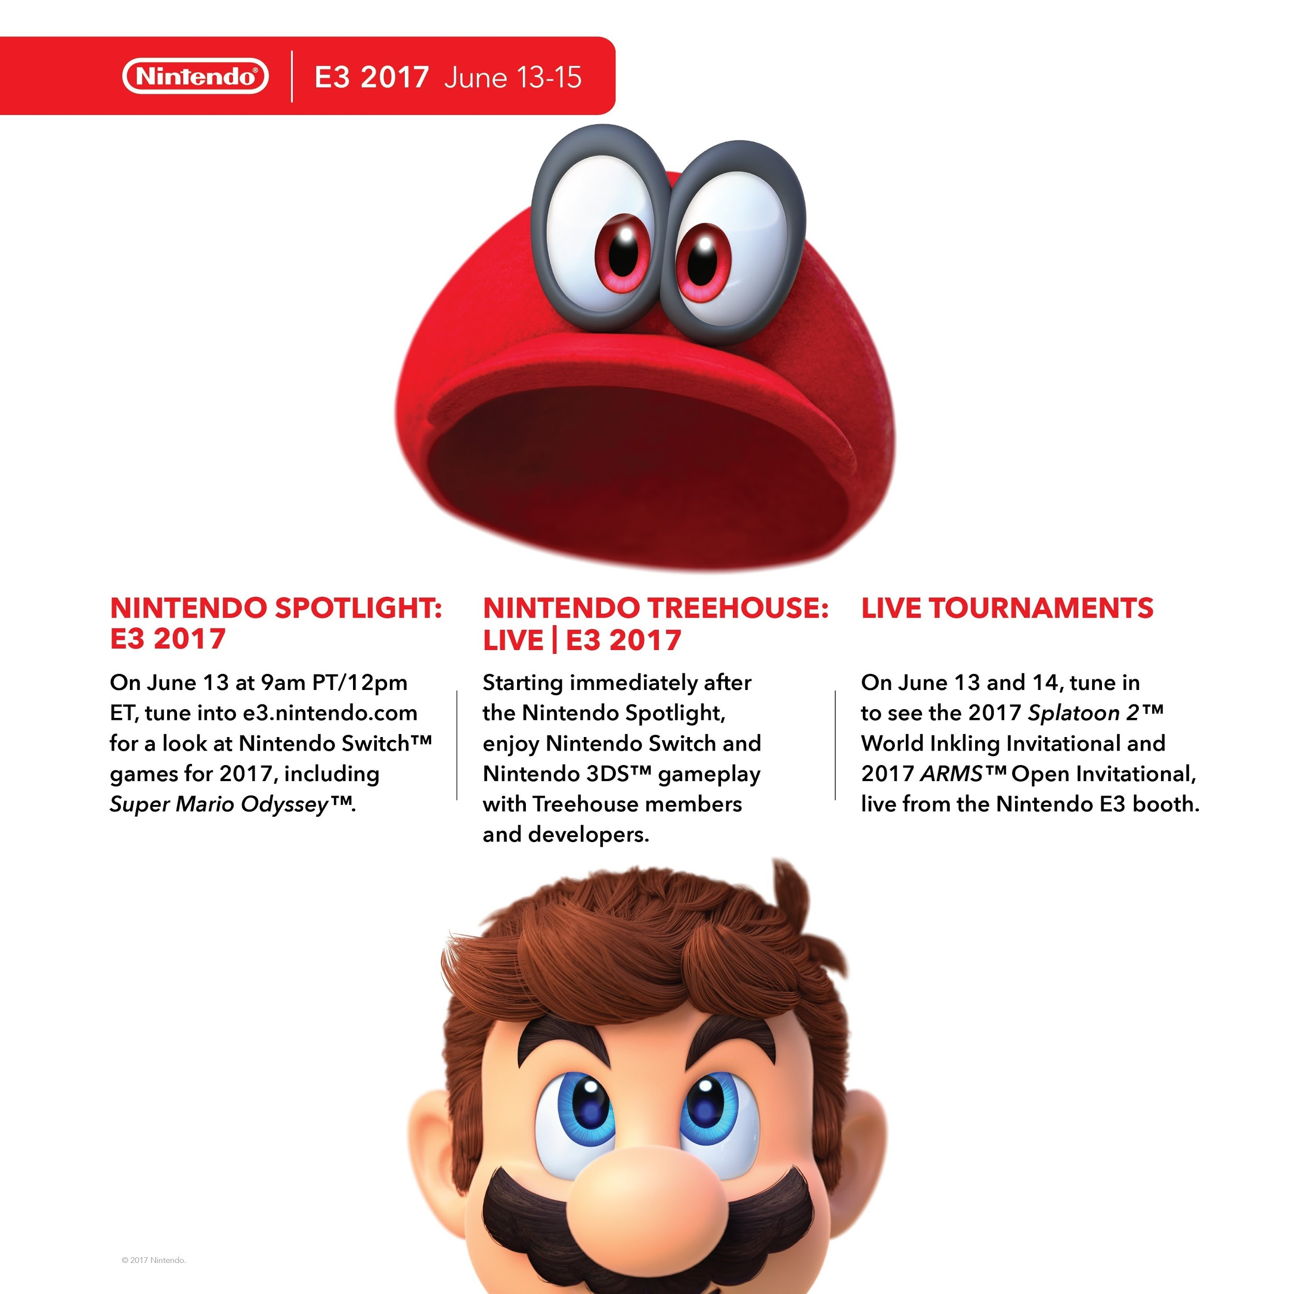

### **Nintendo@E3: Tuesday 13/6, R0.03/4, 4:30pm onwards**

We’ll be streaming the Nintendo Spotlight presentation starting at 5pm, so come along for some live reactions and discussion on upcoming games coming in 2017 including Super Mario Odyssey!



### **Wednesday 14/6, R1.04, 1pm onwards**

Our weekly Smash event returns! With the possibility of returning to more competitive tournaments! The race to the end of year Power Ranking is on!

---------------------------------------------------------------------------------------

Well then, folks, until next time, staaaay fresh!

And Happy Gaming! :D

Timothy Sit

Nintendo Society President

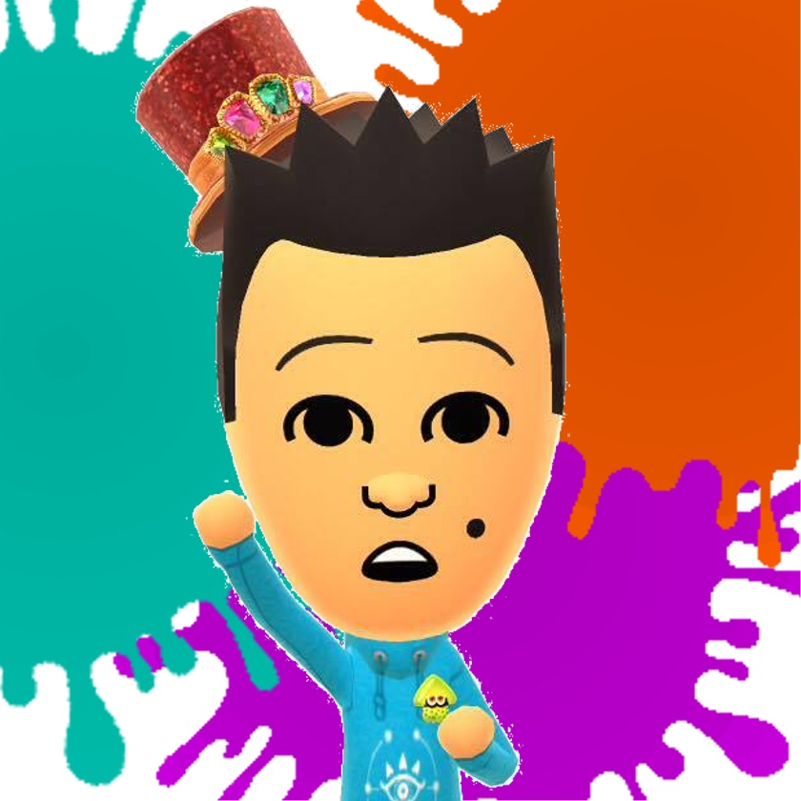

---------------------------------------------------------------------------------------

### **Find us on Social Media:**

Join our Facebook group:<https://www.facebook.com/groups/warwicknintendo/>

Follow our Twitter:<https://twitter.com/warwicknintendo>

Join our Discord Chat:<https://discordapp.com/invite/Rf6QyfG>

Subscribe to our YouTube: <https://www.youtube.com/channel/UCzO_bZNfQDCAQa_zkEUgGVg>